1.     List all customers and the products they ordered with the order date. (Inner join)

**Tables used:** customers, orders, order_details, products

**Output should have below columns:**

    companyname AS customer,

    orderid,

    productname,

    quantity,

    orderdate

 Query

Select c.company_name as customer,o.order_id,p.product_name,od.quantity,o.order_date

From customers c

inner join orders o on c.customer_id=o.customer_id

inner join order_details od on o.order_id=od.order_id

inner join products p on od.product_id=p.product_id;

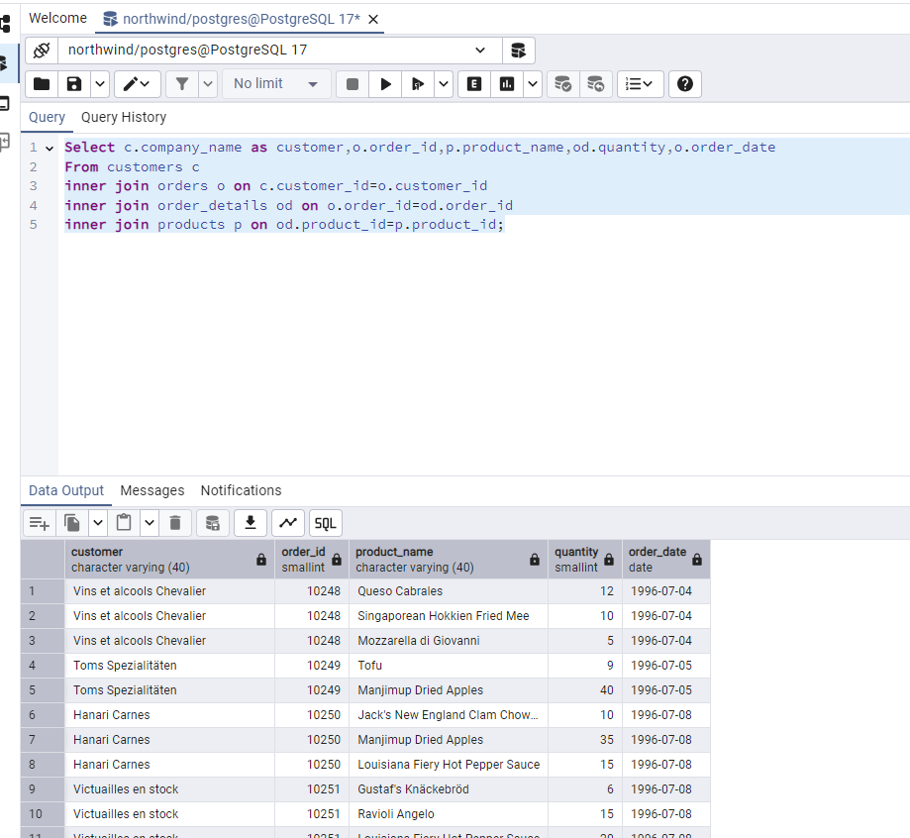

2.     Show each order with customer, employee, shipper, and product info — even if some parts are missing. (Left Join)

**Tables used: orders, customers, employees, shippers, order_details, products**

**QUERY**

SELECT o.order_id,o.order_date,c.customer_id,c.company_name AS customer_name,e.employee_id,

CONCAT(e.first_name, ' ', e.last_name) AS employee_name,s.shipper_id,s.company_name AS shipper_name,

p.product_id,p.product_name,od.quantity,od.unit_price

FROM orders o

LEFT JOIN customers c ON o.customer_id = c.customer_id

LEFT JOIN employees e ON o.employee_id = e.employee_id

LEFT JOIN shippers s ON o.ship_via = s.shipper_id

LEFT JOIN order_details od ON o.order_id = od.order_id

LEFT JOIN products p ON od.product_id = p.product_id

ORDER BY o.order_id;

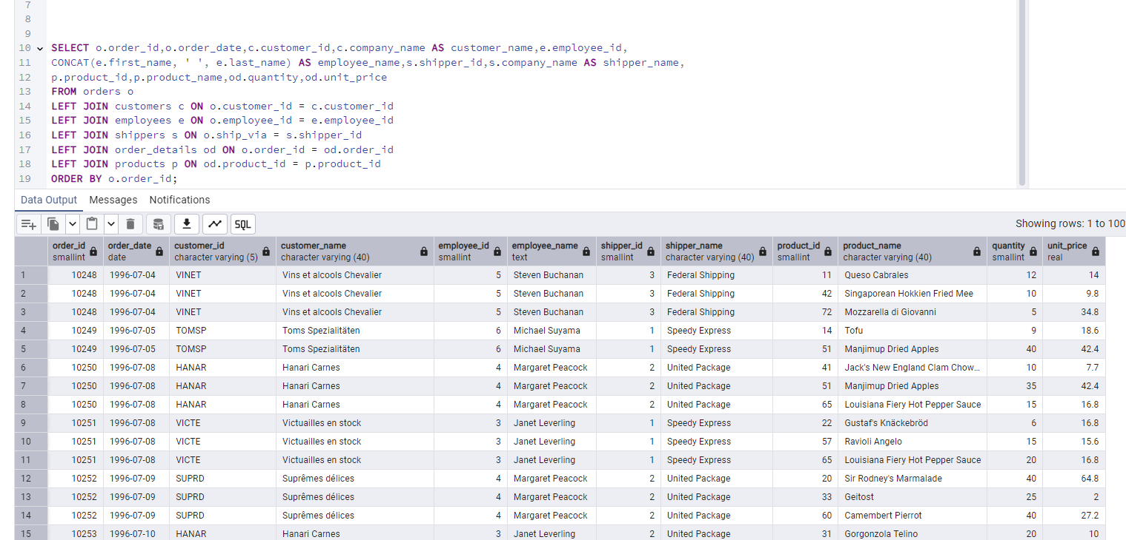

3.     Show all order details and products (include all products even if they were never ordered). (Right Join)

**Tables used: order_details, products**

**Output should have below columns:**

    orderid,

    productid,

    quantity,

    productname

QUERY

SELECT od.order_id,p.product_id,od.quantity,p.product_name

FROM order_details od

RIGHT JOIN products p

ON od.product_id = p.product_id

ORDER BY p.product_id;

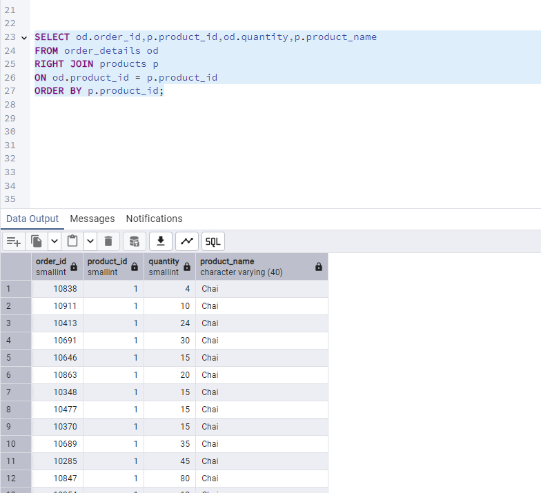

4. List all product categories and their products — including categories that have no products, and products that are not assigned to any category.(Outer Join)

**Tables used: categories, products**

**QUERY**

**SELECT**

c.category_id,

c.category_name,

p.product_id,

p.product_name

FROM categories c

FULL OUTER JOIN products p ON c.category_id = p.category_id

ORDER BY c.category_name, p.product_name;

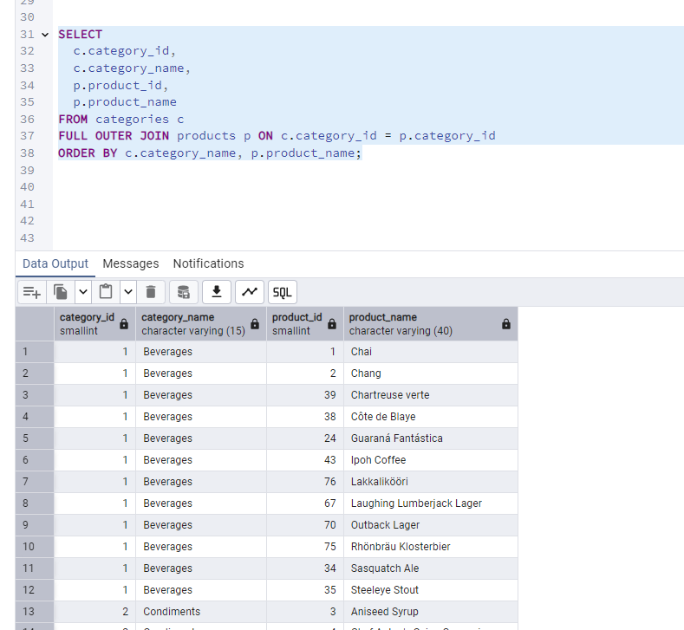

5. Show all possible product and category combinations (Cross join).

QUERY

SELECT p.Product_name, c.Category_name  
FROM Products p  
CROSS JOIN Categories c;

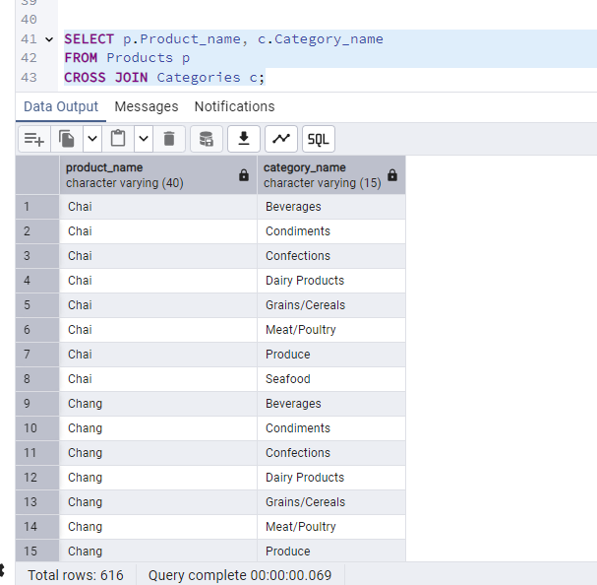

6. Show all employees and their manager(Self join(left join))

QUERY

SELECT  
    e.employee_id AS employee_id,  
    e.first_name || ' ' || e.last_name AS employee_name,  
    e.title AS employee_title,  
    m.employee_id AS manager_id,  
    m.first_name || ' ' || m.last_name AS manager_name,  
    m.title AS manager_title  
FROM  
    employees e  
LEFT JOIN  
    employees m ON e.reports_to = m.employee_id;

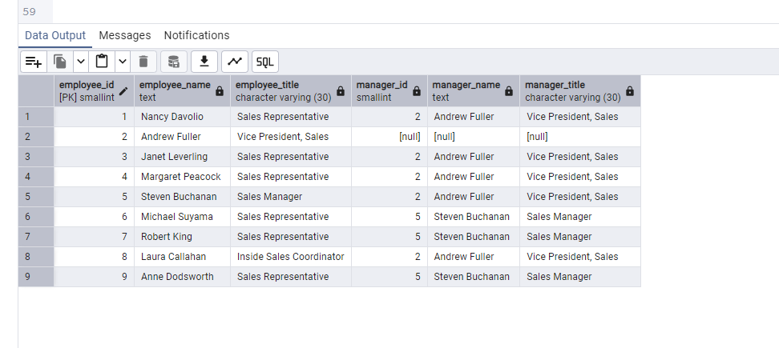

7. List all customers who have not selected a shipping method.

**Tables used:** customers, orders

**(Left Join, WHERE o.shipvia IS NULL)**

**QUERY**

SELECT

c.customer_id,

c.company_name,

c.contact_name,

c.phone

FROM

customers c

LEFT JOIN

orders o ON c.customer_id = o.customer_id

WHERE

o.ship_via IS NULL;

